Partners: Jean Herbst - solution

Laboratory 1

Introduction to MARS and MIPS

Computer Science 240

NOTE: shaded sections of the exercises are questions which you must answer as part of your lab report.

In this lab, you will be introduced to the MARS programming environment in which you will develop MIPS assembly language programs. MARS is installed on the computers in the lab (E125). If you wish to download it to your own computer, it is available online at:

http://courses.missouristate.edu/KenVollmar/MARS/

Basic MARS Use

Exercise 1: Launch MARS from the Start menu.

1. Go to the CS240-L01 Google Group (this group will be used for all lab sections), where all the downloadable materials for lab will be posted. Download the lab1.asm attachment.

2. Launch MARS from the Start menu. You will see something like the screenshot on the next page:
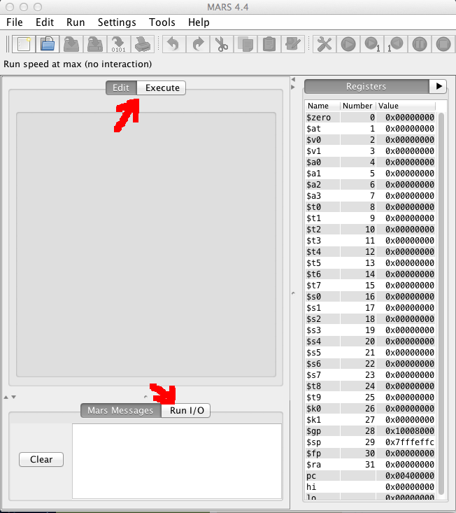
Notice the Edit/Execute tabs and the Mars Messages/Run I/O tabs. These are used to switch between the panels used for those purposes.

Also notice the Registers panel along the right-hand side of the screen. All 32 MIPS registers are labeled and numbered, in addition to 3 more listed at the bottom (the pc , or program counter, and hi and lo registers, which you will learn about later).

Which registers have a non-zero value at this point? sp (stack pointer), pc (program counter)

Explain what the value of the pc indicates: The always contains the address of the next instruction in the program to execute. Since the program is not yet running, the address 0x00400000 is the address of the first instruction in the program.

3. Use File…Open to open lab1.asm, which contains a MIPS program to add two numbers, similar to the one you have seen in lecture. You will see the file open in the Edit panel.

NOTE: (All icons have menubar equivalents; the remainder of these steps will use the icon whenever possible.) 4. Assemble the program using the icon  (also available from the Run menu).

Examine the Mars Messages panel, and notice that the message indicates the assembly was successful.

Also notice that the tab automatically changes from Edit to Execute, and that the Text Segment and Data Segment panels are now displayed (similar to the earlier screenshot).

What does the 0x notation mean which precedes the 8-digit numbers you see displayed in these panels?
0x indicates the number is in hexadecimal (base 16) format.
5. The Text Segment contains the code from the .text section of the program (the program instructions). Explain what you think each column in this panel is used for:

Bkpt: Indicates if a breakpoint is set at this address

Address: Location in memory of the specified instruction

Code: Machine code (numeric representation) for the instruction

Basic: Assembly language version (using core MIPS instruction set) of the instruction

Source: Actual source from your file (may differ from the Basic instruction if source contains pseudo-instructions)

6. What is the starting address of the program? 0x00400000

7. The Data Segment contains the code from the .data section of the program (the variables and constants defined in the program). What is the starting address of the Data Segment? 0x10010000

8. Each row in the Data Segment lists the contents of 8 words in memory, each of which contains 32 bits, or 4 bytes, of data. Notice that the first 7 words in the Data Segment contain non-zero values. Why are these non-zero for this program? The ascii values for the characters in the string “Enter a value:” are stored here.

9. Use the Settings menu to configure the MARS displays. The settings will be retained for the next MARS session.
- The Labels display contains the addresses of the assembly code statements with a label, but the default is to not show this display. Select the checkbox from the Settings menu. 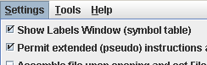
- Select the checkbox to allow pseudo-instructions (programmer-friendly instruction substitutions and shorthand).
- Select the startup display format of addresses and values to be hexadecimal.

10. Use the slider bar to change the run speed to 1 instructions per second. 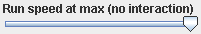 This allows us to “watch the action” instead of the assembly program finishing directly.

11. There are a number of ways to execute the program:

- The  icon runs the program to completion. Using this icon, you should observe the yellow highlight showing the program’s progress in the Text Segment, and green highlight showing the registers being modified in the Registers panel. When there are changes to the Data Segment, they are also highlighted.
- The  icon resets the program and simulator to initial values. Memory contents are those specified within the program, and register contents are generally zero.
- The  icon is “single-step.” Its complement is , “single-step backwards” (undoes each operation).

12. Run the program to completion, using the very slow 1 second per instruction speed. You will need to enter values twice in the Run I/O panel, to be used for the addition. Upon completion, the following will be displayed:
Enter a value:2
Enter a value:3
The sum is:5
program is finished running –

13. Reset and run the program one instruction at a time, using the single-step . Examine the registers after each instruction to verify that you understand any new values.

14. Set a breakpoint at address 0x400038 by clicking on the checkbox at the left of the instruction.

- Reset and run the program again, which stops at the breakpoint, before executing the instruction.
- Examine the value of $t2 at this point. What is it? 2
- Perform a single step is to execute the add instruction.
- Examine the value of $t2 again. What is it now? 5
- Click to continue from the breakpoint.

NOTE: you can modify register or memory values directly at a breakpoint before continuing, if it is necessary to do so for testing purposes.

15. Open the Help  for information on MIPS instructions, pseudoinstructions, directives, and syscalls.

Exercise 2: Now that you have seen the basic operation of MARS, try and write your own program! Modify the add program so that it prompts you for your name and age, and outputs a message that greets you and tells you how old you will be in 4 years.

# to read in a string, do the following. The string will be stored in memory at location “answer”
li $v0,8 # system code for read string
la $a0,answer #put address of answer string in $a0
lw $a1,alength #put length of string in $a1
syscall

#you also need the following definitions in your .data section for this to work:
answer: .space 51 #will hold up to 50 characters, so the name must be 50 characters or less

alength: .word 50

When you run your program, your console should look like the following:

What is your name? Wendy Wellesley
What is your age? 20

Hello, Wendy Wellesley
You will be 24 years old in four years

Format and comment your program appropriately, and upload it to your Google Drive. Share with your partner
and instructor.

.data
prompt1: .asciiz "What is your name? "
prompt2: .asciiz "What is your age? "
prompt3: .asciiz "You will be "
prompt4: .asciiz " years old in four years."
name: .space 50
length: .word 50
age: .word 0

.text
li $v0,4
la $a0,prompt1
syscall

li $v0,8
la $a0,name
la $a1,length
syscall

li $v0,4
la $a0,prompt2
syscall

li $v0,5
syscall
addi $t0,$v0,4
sw $t0,age

li $v0,4
la $a0,prompt3
syscall

li $v0,1
lw $a0,age
syscall

li $v0,4
la $a0,prompt4
syscall

li $v0,10
syscall

If you need to print a hardcopy, the two printers in the Science Center which are configured for the lab computers are:

MF Left (located in the Micro-Focus, opposite my office E129)
MF Right (located in the basement, near the elevators outside the Science Library)

Please use double-sided if your programs are more than 1 page long, to save paper.

To print the output of a program, hit the Prnt Scrn key on your keyboard. This puts the screen in a Copy Buffer, which you can then paste into a Word document.

Exercise 3: Begin editing a source file for a new MIPS program.

1. Type in the following program (you don’t have to type the #comments), and save as lab1-2.asm on the desktop:

.text
.globl main

main: li $v0,4 #load sys call code for print string to $v0 (contract for syscall)
la $a0,prompt #address of string to print
syscall #print the string

li $v0,1 #sys call for print integer
lb $a0,val #load the integer to print to$a0 (contract for syscall)
syscall #print it

addi $t0,$t0,1 #increment the value of $t0

li $v0,10 #sys call for exit
syscall

.data
prompt: .asciiz “your code is: “
val: .byte 8

Assemble the program. If you have typed the program in with no syntax errors, the Mars Messages window should tell that your program loaded successfully. Run the program to observe its simple output.

2. Examine the Data Segment. Record the values shown for the first 16 bytes in data memory (write exactly as shown in the MARS data segment, where 4 bytes are grouped together in each entry):

Data Segment
Address Value (+0) Value (+4) Value (+8) Value (+C)
0x1001000 0x72756f79 0x646f6320 0x73692065 0x0800203a
3. Record the address and data contents of each byte location in the Data Segment using the stack model of memory.

- Show one byte per row.
- Lowest address should be at bottom of stack.
- Label the address which corresponds to the start of the prompt string
- Label the address which corresponds to val (NOTE: the Labels panel lists the addresses).

Address Label | Data
0x10010010 val  0x1001000f  0x1001000e  0x1001000d  0x1001000c  0x1001000b  0x1001000a  0x10010009  0x10010008  0x10010007  0x10010006  0x10010005  0x10010004  0x10010003  0x10010002  0x10010001  0x10010000 prompt |  | What is the meaning of the first byte that has a 00 value?  Null character terminating the string  Where does the value of 08 come from in the byte with that value? The variable ‘val’ is initialized to a value of 8
  08
  00
  20
  3a
  73
  69
  20
  65
  64
  6f
  63
  20
  72
  75
  6f
  79

Exercise 4:
1. Create another source file containing the following program, and save it as lab1-3.asm:

.text
.globl main

main: li $v0,10 #sys call for exit
syscall

.data
nums: .byte 4,3,2,1
.half 8,7,6,5
.word 1,2,3,4
.space 1
.word 12
letters: .asciiz “EFG”
.ascii “efg”
neg1s: .byte -1,-1
.word 15

2. Before running the program, predict the contents of data memory (use hexadecimal values, but to save space, omit preceding the numbers with 0x):

Data Segment
Address Value (+0) Value (+4) Value (+8) Value (+C) Value (+10) Value (+14) Value (+18) Value (+1C)
0x10010000 01020304 00070008 00050006 00000001 00000002 00000003 00000004 00000000

0x10010020 0000000c 00474645 ff676665 000000ff 0000000f

3. Record the address and data contents of the Data Segment using the stack model of memory.

- This time, show one word (4 bytes) per row.
- Lowest address should be at bottom of stack.
- Label the addresses corresponding to nums, letters, and neg1s

Address Label | Data
0x1001002c  0x10010028 neg1s (1001002C)  0x10010024 letters  0x10010020  0x1001001c  0x10010018  0x10010014  0x10010010  0x1001000c  0x10010008  0x10010004  0x10010000 nums
  00 | 00 | 00 | 0f
  ff | 67 | 66 | 65
  00 | 47 | 46 | 45
  00 | 00 | 00 | 0c
  00 | 00 | 00 | 00
  00 | 00 | 00 | 04
  00 | 00 | 00 | 03
  00 | 00 | 00 | 02
  00 | 00 | 00 | 01
  00 | 05 | 00 | 06
  00 | 07 | 00 | 08
  01 | 02 | 03 | 04

Assemble the program, and examine the Data Segment/verify that the data is stored in memory as you predicted.
Exercise 5: Consider the following program (you don’t need to create a new source file, just read the code and answer the questions):

.text

la $s0,neg1byte
la $s1,oneword
la $s2,twowords
la $s3,smallstring
lb $t0,3($s1)
add $s1,$s1,$t0
lb $t1,0($s1)
addi $s1,$s1,2
add $s2,$s1,$t1
sb $t0,0($s2)
addi $s1,$s1,7
add $a0,$s1,$t0
li $v0,4
syscall
lw $t0,0($s3)
sh $t0,-5($s2)
li $v0,10
syscall

.data
neg1byte: .byte -1

oneword: .word 0x02030405

twowords: .word 02,03

smallstring: .asciiz “abc”

halfwords: .half 10,11,12,13,14,15

Assume that neg1byte represents address 0x10010000, and that all unspecified bytes in memory contain 00.

1. How many bytes are allocated in the data section, from the starting address neg1byte to the end of the data stored at halfwords (count any extra bytes allocated by the data directives)? 32 bytes

List your predicted values for the bytes stored in the Data Segment before the program executes:

Data Segment
Address Value (+0) Value (+4) Value (+8) Value (+C) Value (+10) Value (+14) Value (+18) Value (+1C)
0x10010000 000000ff 02030405 00000002 00000003 00434241 000b000a 000d000c 000f000e

2. Fill in the following table to show the contents of registers $s0-s3 and $t0-$t1 after each instruction is executed.

Only fill in the entries that change for each instruction. If a value stored in memory is modified by an instruction, also record that address and it’s new value on that line. Assume all registers contain a value of 0 initially!

$s0 $s1 $s2 $s3 $t0 $t1 $a0 addr: val

la $s0,neg1byte 10010000

la $s1,oneword 10010004

la $s2,twowords 10010008

la $s3,smallstring 10010010

lb $t0,3($s1) 00000002

add $s1,$s1,$t0 10010006

lb $t1,0($s1) 00000003

addi $s1,$s1,2 10010008

add $s2,$s1,$t1 1001000b

sb $t0,0($s2) 1001000b: 02

addi $s1,$s1,7 1001000f

add $a0,$s1,$t0 10010011

li $v0,4 (prints the string stored at address in $a0)
syscall

lw $t0,0($s3) 00434241

sh $t0,-5($s2) 10010006: 4241

What should be displayed in the Run I/O window at the end of the program? bc

Record your predicted values of the bytes stored in the data section after the program is done executing (just record the new values in memory, in the correct location; don’t rewrite your whole table):

Data Segment
Address Value (+0) Value (+4) Value (+8) Value (+C) Value (+10) Value (+14) Value (+18) Value (+1C)
0x10010000 000000ff 02030405 00000002 00000003 00434241 000b000a 000d000c 000f000e
4241 02

